Ridge Regression:

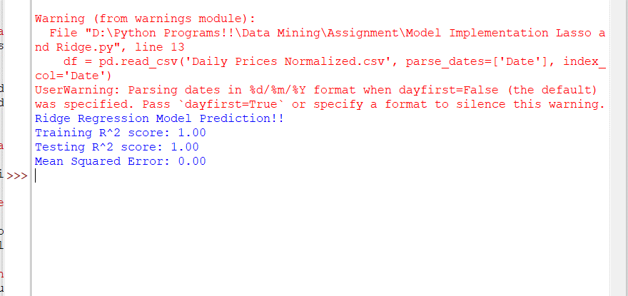

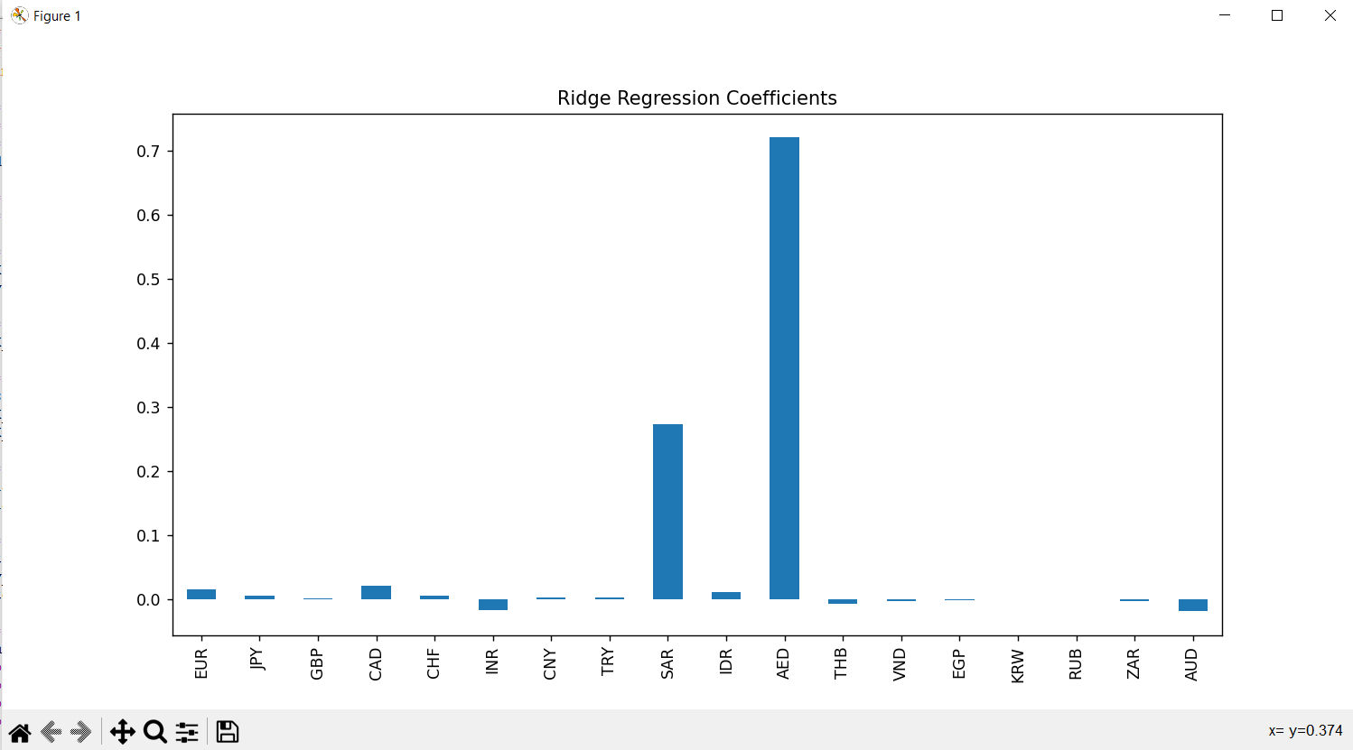

Lasso Regression:

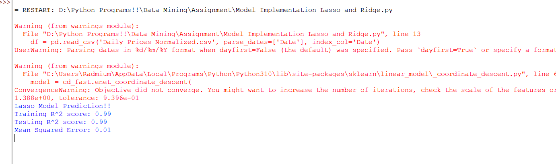

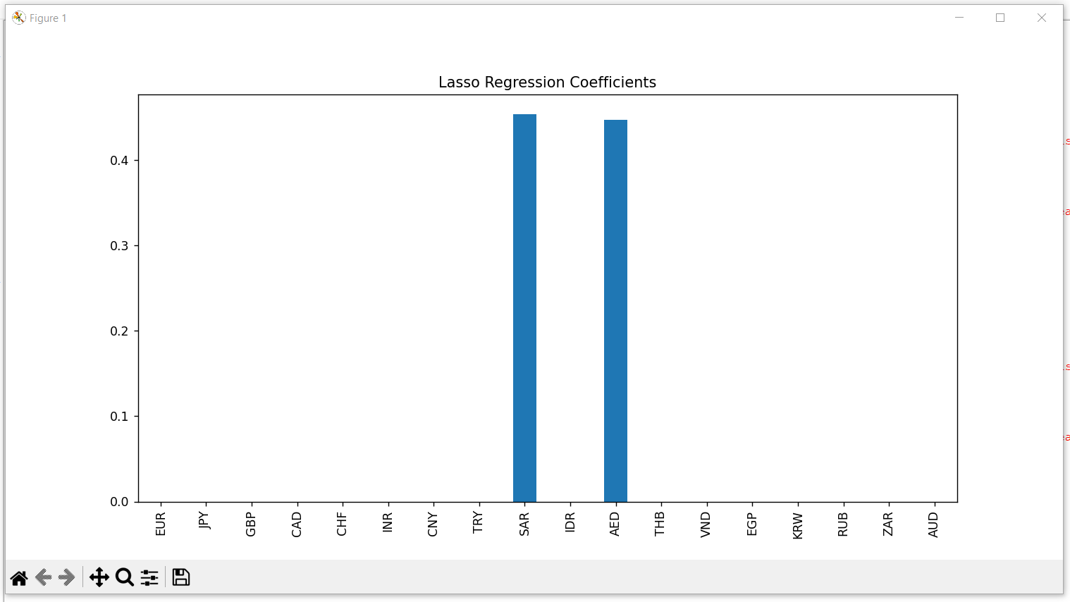

Polynomial Regression:

Hyperparameter Tuning:

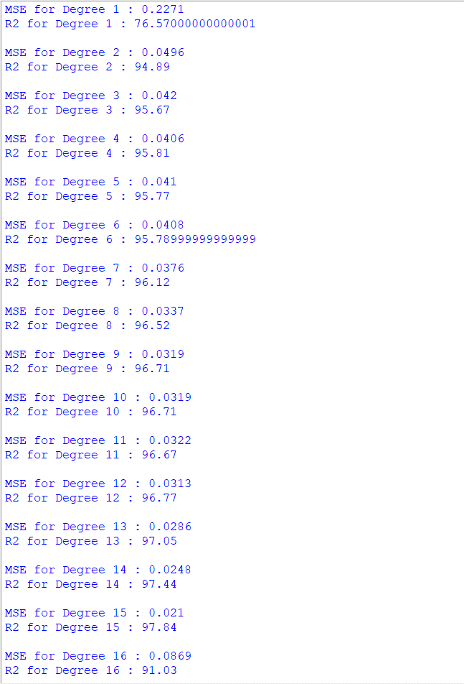

It is evident from given data that degree 15 best suits or data set!!